Project 3-1

Bharadwaj Mulukudithi

04/19/2023

1. Add two layers - (in R or Colab) (Specifying parameters for each layer in the code)

* Convolutional layer with kernel size 3 x 3 with relu
* Maxpool with size 2 x 2

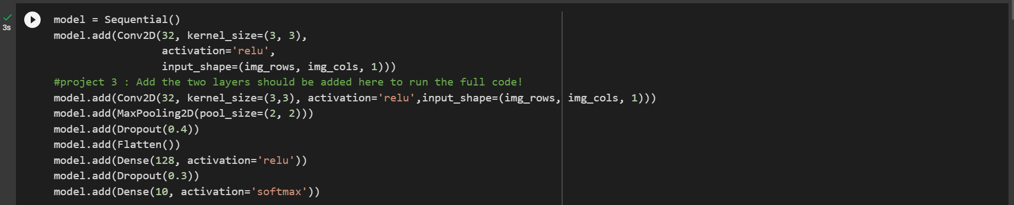

1. Print the model summary and report how many total layers are there now?

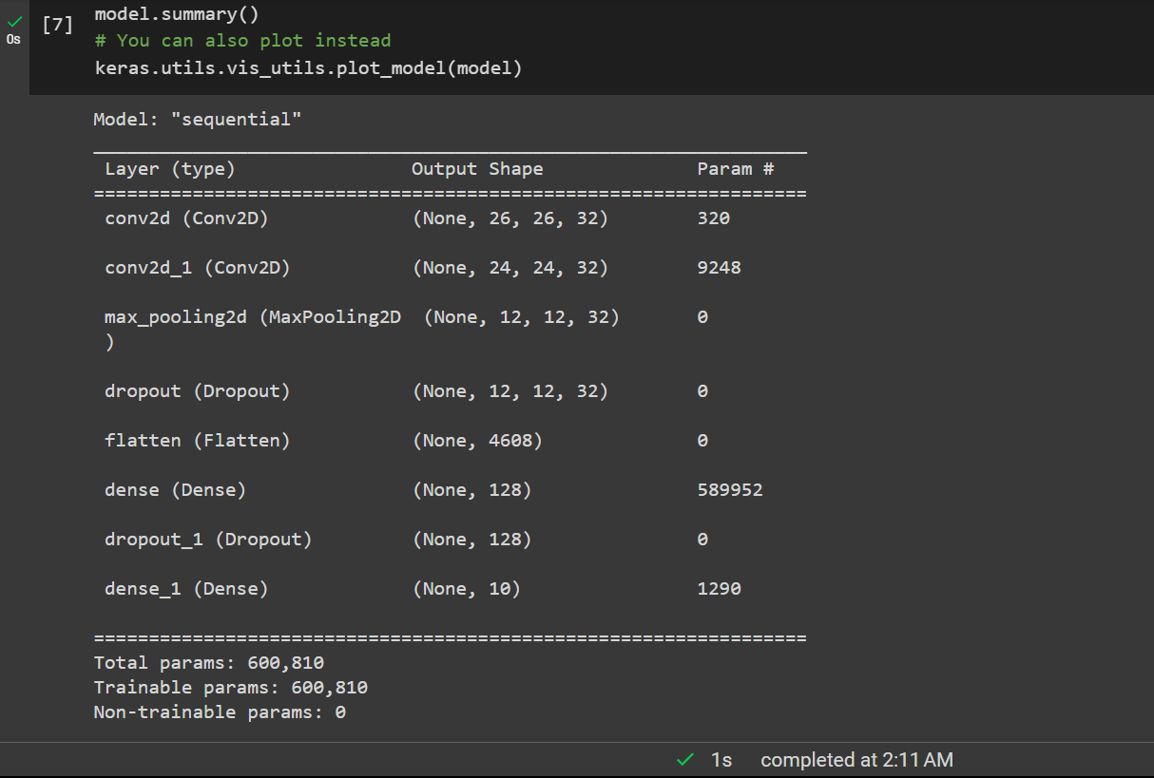

From the image below, we can say that there are 8 layers in the model. Two new layers i.e., one convolutional layer and another Maxpool layer are added to the existing 6 layers.

The arrangement of layers can be seen in Figure 1.

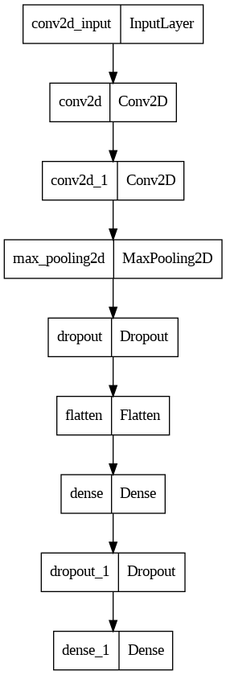

Figure 1: Model layer plot

1. How many trainable parameters are there now? Did it reduce or increase and why?

The total number of Trainable parameters has increased as the number of layers increased from 235,146 to 600,810.

This is because we added new layers to the model. Each layer has its own set of trainable parameters (weights and biases), and adding more layers increases the number of parameters that need to be trained during the training process. In this case, we added a convolutional layer with 64 filters and a kernel size of 3 x 3, which has 32 \* (3 \* 3 \* 32 + 1) = 9,248 trainable parameters, and a max pooling layer with a pool size of 2 x 2, which has no trainable parameters.

1. Make sure you ran the full code with these two additional layers, and report the final training accuracy value, test accuracy value

The complete code is compiled with two additional layers from 30 epochs with training and testing data sets.

The accuracy of the trained model is 0.9965 at the 30th epoch.

The accuracy of the test model is 0.9926999807357788

